Gavin Sit

215 043 870

EECS 2021E

**Part 1**

Code:

ORG 96

DD 5

addi x1, x0, 96

ld x2, 0(x1)

ecall x3, x0, 5

bge x2, x3, L1

addi x5, x0, 1

beq x0, x0, Exit

L1:addi x5, x0, 0

Exit: sd x5, 8(x0)

After compiling:

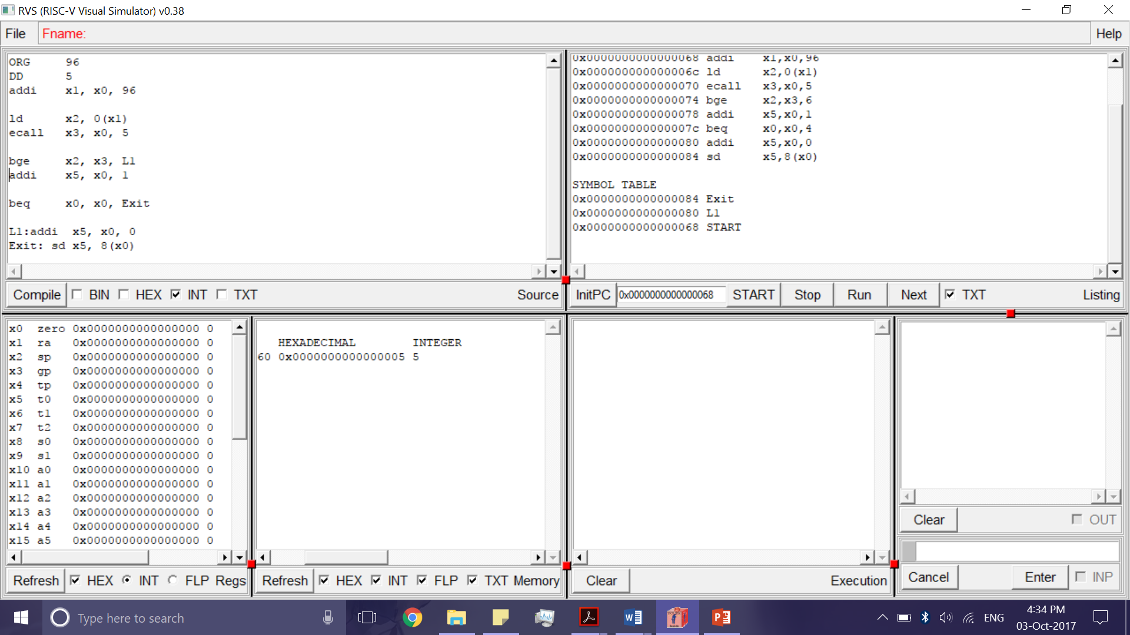

After running:

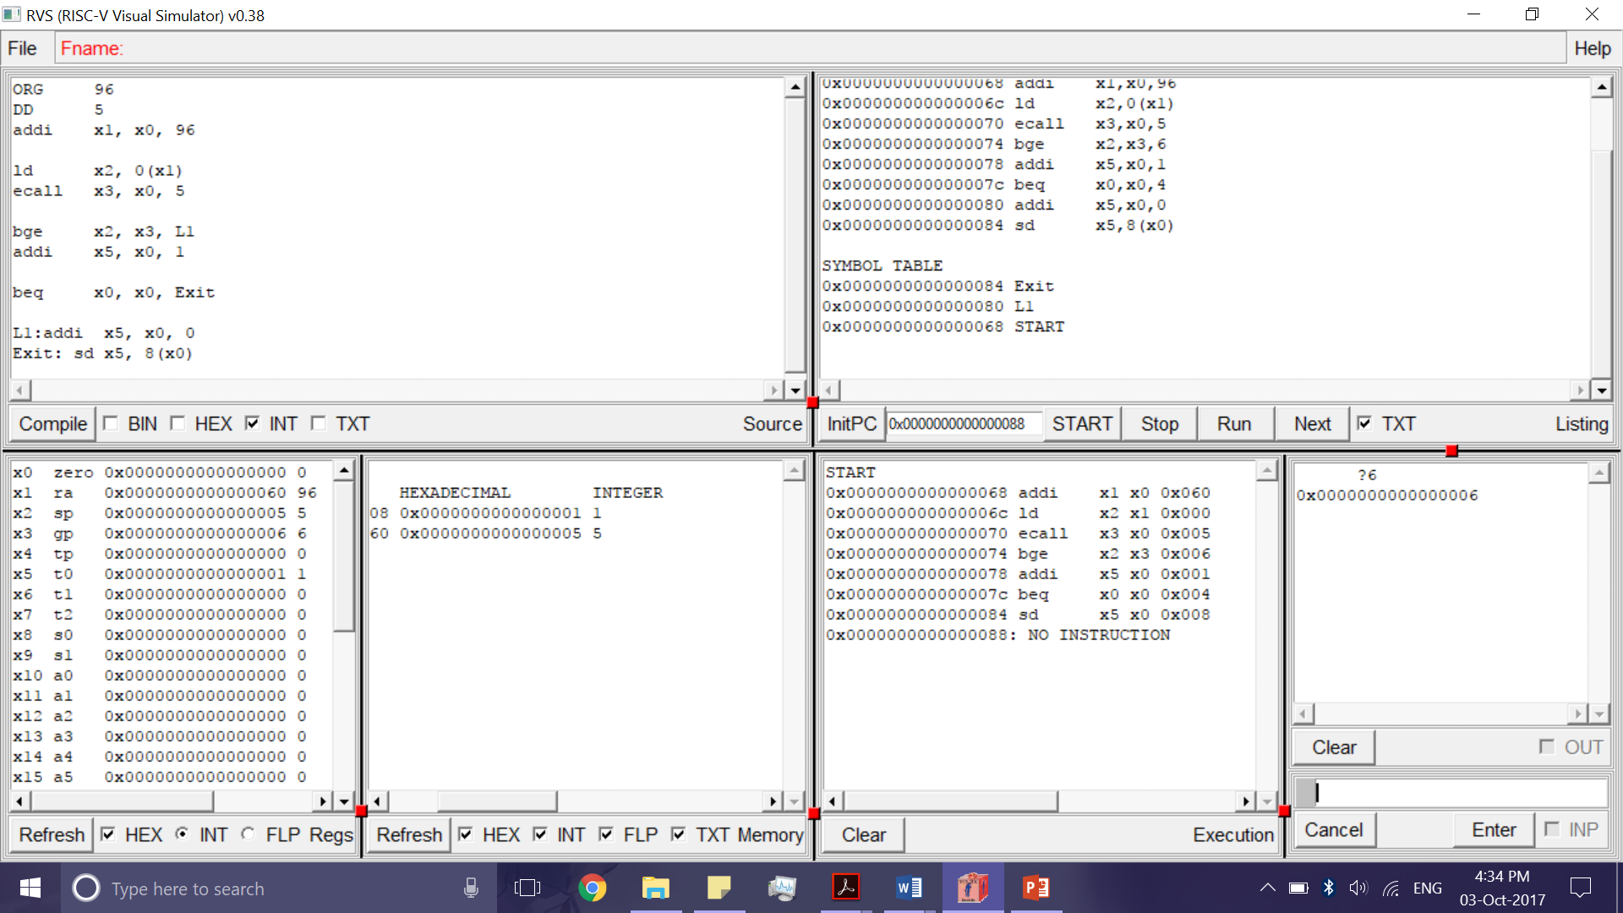

**Part 2**

Code:

ORG 96

DD 5

addi x1, x0, 96

ld x2, 0(x1)

ecall x3, x0, 5

bge x2, x3, L1

addi x4, x0, 5

addi x5, x0, 5

beq x0, x0, Exit

L1: beq x2, x3, Equal

addi x4, x0, 1

addi x5, x0, 2

beq x0, x0, Exit

Equal: addi x4, x0, 0

addi x5, x0, 0

beq x0, x0, Exit

Exit: sd x4, 8(x0)

sd x5, 16(x0)

After Compiling:

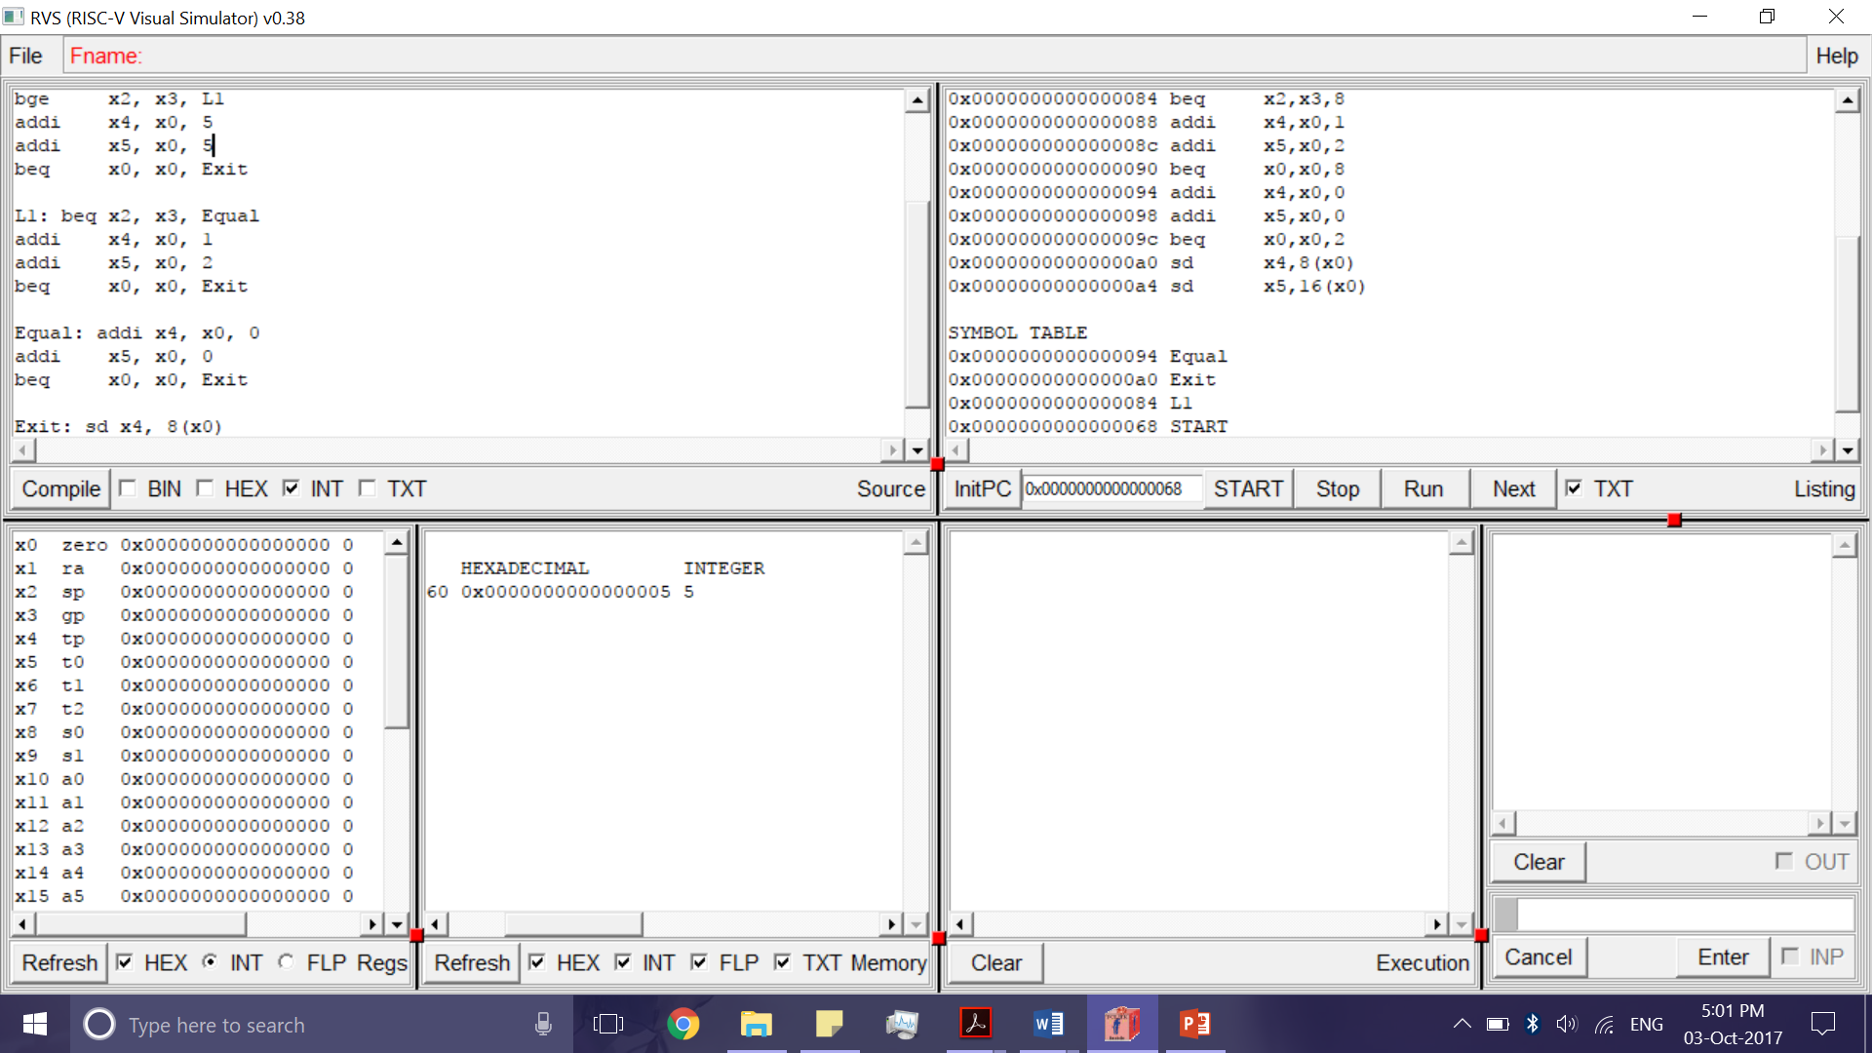

After Running:

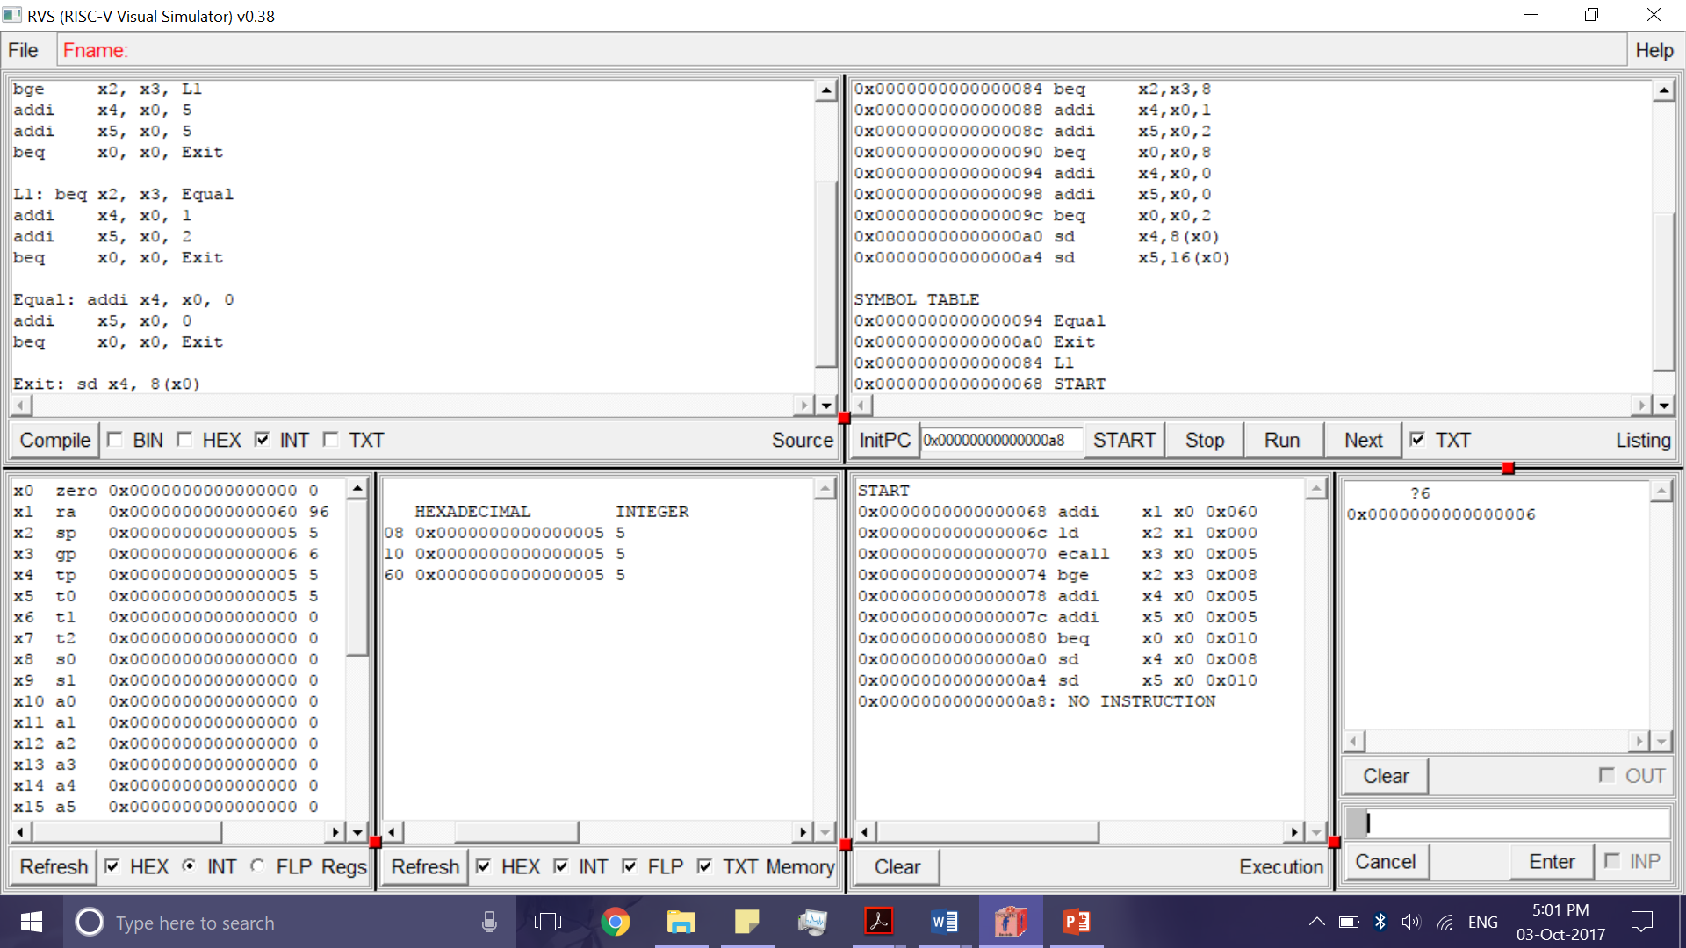

**Part 3**

Code:

ORG 96

DD 10, 5

addi x1, x0, 96

addi x7, x0, 5 //stores value 5 to be compared

ecall x2, x0, 5 //A

ecall x3, x0, 5 //B

ecall x4, x0, 5 //C

//x5 and x6 are the y and z values

blt x3, x2, GreaterThan

addi x5, x0, 0

addi x6, x0, 0

beq x0, x0, Exit

GreaterThan: beq x4, x7, Equal

addi x5, x0, 0

addi x6, x0, 0

beq x0, x0, Exit

Equal: addi x5, x0, 1

addi x6, x0, 2

beq x0, x0, Exit

Exit:sd x5, 8(x0)

sd x6, 16(x0)

After Compiling:

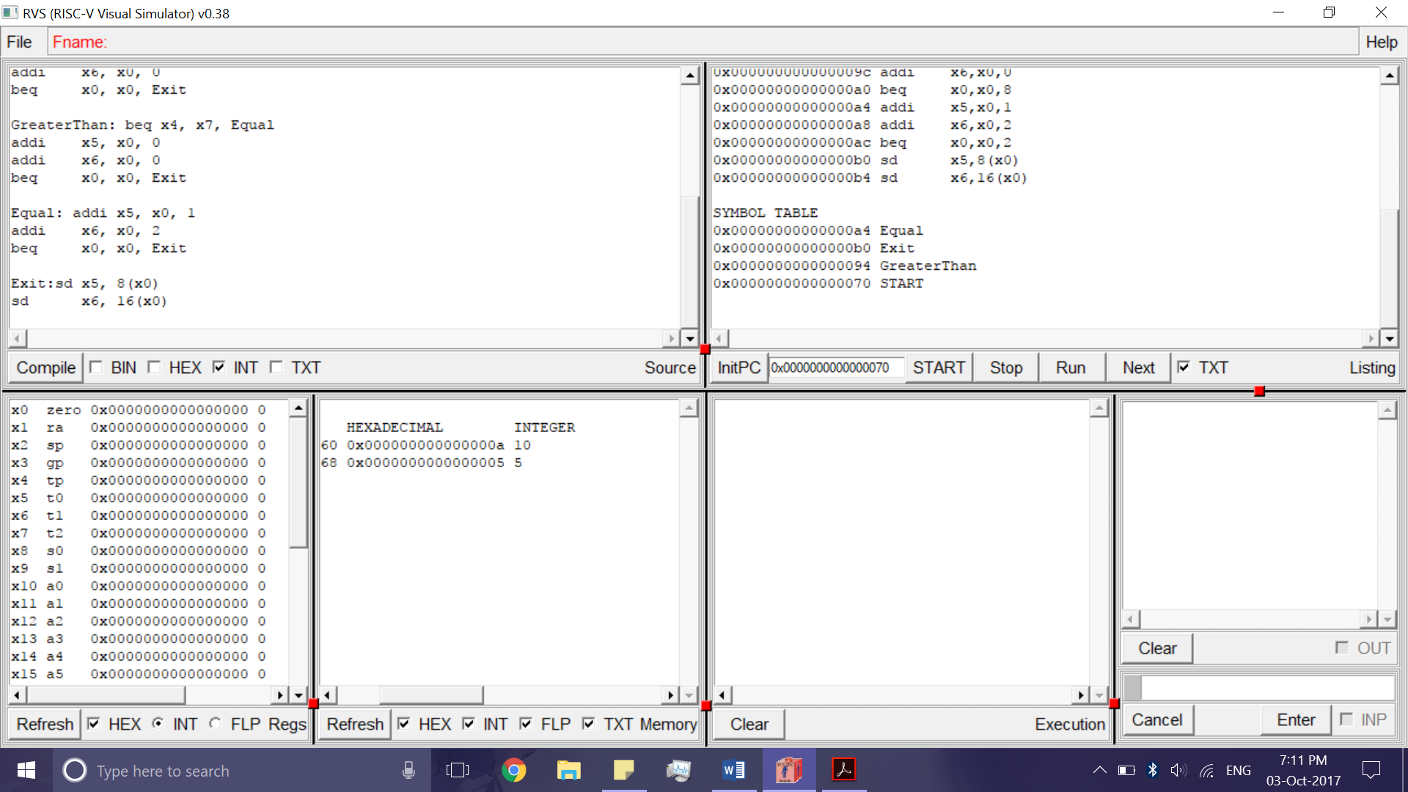

After Running:

